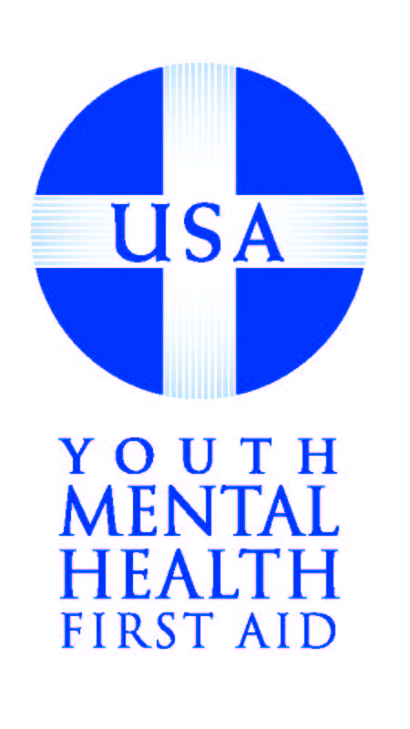

Youth Mental Health First Aid
Instructor Certification Program Application Packet

Thank you for your interest in becoming certified to teach Youth Mental Health First Aid. For those new to MHFA instructor certification, the Youth Mental Health First Aid certification program is a full 5-day training after which attendees are certified to offer the 8-hour Youth Mental Health First Aid course to members of the general public. For existing MHFA instructors already certified to teach the standard Core “Adult” Mental Health First Aid course, the Youth Mental Health First Aid certification requires an additional 2.5 days of training, to be completed during the first half of the allotted 5-day training period.

We recommend that each community send at least two participants. In order to accommodate a variety of communities in the class, we request that you do not plan for more than two participants from your community to attend. Should you plan to send more or fewer participants, please explain your rationale in the questionnaire section.

Each participant must review this entire document & sign the attestation page before attending the training.

Fees: For those applying for the full 5-day attendance, tuition is $2,000 per person ($1,850 for National Council members). If selected, your organization will be responsible for participant tuition, travel, hotel, and any miscellaneous expenses during the week of training. For existing instructors attending the first 2.5 days, tuition is $950 per person ($850 for National Council members). After being certified as an instructor for MHFA, each instructor may charge a fee or build that into the course tuition when teaching Youth Mental Health First Aid.

The number of 8-hour Youth Mental Health First Aid trainings you are able to offer each year may vary based on the organization and target audiences, but certified instructors are expected to offer at least three trainings per year to maintain certification.

Please return your completed application via email to us at MHFAapplications@thenationalcouncil.org.

Cover Sheet

YMHFA Instructor Training Location & Dates: _____________________________________

Applicant Information: (provide contact information for each individual applying)

Name
Title
Organization
Email
Daytime Phone
Secondary Phone
Postal Address
Training Needed | - Expedited 2.5 day (certified MHFA adult instructor) | - 5-day (new participant)

Name
Title
Organization
Email
Daytime Phone
Secondary Phone
Postal Address
Training Needed | - Expedited 2.5 day (certified MHFA adult instructor) | - 5-day (new participant)

If certified in YMHFA-USA, when would you offer your first training?

MHFA Primary Contact
at your Organization:
Position/Title:
Email Address:
Telephone: | (_____)____-_______________
Does your organization have an active public education program? |  |  |  |  | ___YES |  | ___ NO
What is your organizational structure? __Private __Public __Non-Profit _for Profit __ Other

Which most closely describes your service area? |  | __Frontier | __Rural | __Suburban |  | __Urban |  | __Other

Instructor Certification Requirements & Expectations

A Youth Mental Health First Aid Instructor is a person who is certified to teach the 8-hour Youth MHFA-USA course to members of the general public. The following outlines the certification process, certification maintenance, and privileges for Youth Mental Health First Aid Instructors.

Instructor Training
The MHFA Instructor training is held over five days and is taught by two authorized MHFA trainers connected to at least one of the Mental Health First Aid – USA Authorities. Only participants who have been present for the entire 5-day training (or 2.5 day, if already certified in the adult course) will be considered for certification as instructors. During the training, each participant will present an assigned 30 minute portion of the 8-hour Youth MHFA course to the group. Trainers will conduct an individual evaluation of each participant in addition to the peer feedback provided. Participants are expected to be active in providing peer reviews on days four and five. In addition to the presentation, each participant must complete and pass a written exam prior to the end of the training. Each of the above items determines whether or not an individual is granted certification to teach the Youth MHFA course. It is not guaranteed that all participants who attend the instructor training will achieve certification. Certification applies to the Youth Mental Health First Aid course only; Additional training is required for individuals to become certified to teach the adult Mental Health First Aid course.
Certification Maintenance
To maintain certification, each MHFA-USA Instructor is required to:
- Teach their first course within 6 months of training and teach at least three MHFA-USA courses per year.
- Present the current program in accordance with the course outline, objectives and key messages, and materials provided upon certification: While instructors should add local resources, contact information and examples, they cannot otherwise alter course materials in delivering MHFA to public audiences. MHFA-USA welcomes any questions or concerns relating to the fidelity of the program in community presentations.
- Collect evaluations from each course participant to whom a certificate is issued. In order to standardize evaluations nationwide, instructors must use the standard youth course evaluation form provided in the teaching kit and on the Technical Assistance site.
- Report this evaluation information to MHFA-USA to ensure you are delivering the program on a regular basis, maintaining acceptable evaluations from participants, and to help evaluate how the program is received nationwide.
- Respect the privacy of course participants, colleagues and others, including the responsibility to protect personal information when gathering information on registration forms or in submitting evaluations; or in gaining permission prior to sharing personal stories or experiences of others.

Once certified, instructors are granted access to a variety of materials designed to help develop and present the program, including:
- Registration on the Instructor Technical Assistance Website: Allows access to program materials and resources needed to teach and promote the youth course, including course PowerPoint, handouts & exercises, evaluation forms, certificate template, and a variety of marketing and business development templates.
- Enrollment in the MHFA-USA Listserve: Instructors nationwide can connect, discuss MHFA-related questions, and share news about developments in your community.
- Access to Continuing Technical Assistance from MHFA - USA: Any further questions, comments, or concerns relating to the delivery or development of the course, we are available to speak with instructors directly or to connect with other instructors who may have a shared interest or specialty.

Questionnaire

Please answer the following questions so we may assess your fit with the selection criteria for becoming an Instructor for Youth Mental Health First Aid – USA (YMHFA –USA) (see page 5 for full criteria). In particular, please include specific examples of your experience with MHFA-USA to date (if any), relevant experiences and accomplishments (including the instruction of adult populations, facilitation of diverse groups, and familiarity with mental health and substance use information), and what you plan to do with the program.

- How does YMHFA complement the services and/or trainings you or your organization currently offers in your community?

- Please outline specific experiences and/or skills you have that are relevant to your facilitating the YMHFA course. Include in relevant skills in training/educating adult groups, and experiences in working with youth.

- Mental Health First Aid is a public education program designed to appeal to a wide variety of audiences, particularly individuals with no background in mental health. Given the range of potential audiences for this program, who do you envision as your primary target audience(s) for YMHFA? Please identify initial and long-term potential audiences, including a tentative timeline for your roll-out of the program. Identify any group(s) to whom you are particularly suited to deliver the course and explain why.

- Do you know of any other certified MHFA or YMHFA Instructors in your community? If so, do you plan to coordinate with them to provide the program, or how will you serve your community differently?

- Please describe your plan for promoting and funding YMHFA if you are certified. Include any relevant information from a business plan, organizational support, or other elements which demonstrate long-term development and sustainability for the program.

- What is your motivation for wanting to be a YMHFA-USA Instructor?

- A goal of MHFA-USA is to reduce the negative attitudes and discrimination towards people with mental health problems. What factors do you believe create and maintain the unfavorable attitudes some people have towards individuals with mental health problems?

Application Considerations & Attestation

The ability to effectively deliver Mental Health First Aid nationwide is dependent on the quality of the instructors and their dedication to and enthusiasm for the program. The Youth MHFA course may only be taught by certified Youth MHFA instructors, who participate in a rigorous process to ensure the highest standard is maintained & their role as an instructor is clearly defined. As such, this application packet is designed to both let us learn about your plan & for you to learn about how instructors fit into ours as part of the larger vision for Mental Health First Aid in the US, so we expect you will give it careful attention.

Selection Criteria
MHFA instructor applicants are expected to come to the instructor training with an extensive knowledge of mental health (personal or professional) and to possess teaching skills or related training experience.

Each MHFA instructor must have the mental health knowledge and experience to be able to facilitate discussions and answer questions within the key messages of the 8-hour course, and can identify mental health services within their state and community. In their responses to the above questions, applications should highlight any experience of participants related to the instruction of adult populations, the ability to effectively facilitate diverse groups, and the competency/flexibility to create and maintain a positive learning environment.

Both agency or corporate employees and independent individuals may become certified to deliver the Youth MHFA course. In either situation, outlining a plan for teaching the course, and one’s experience in reaching community partners, must be included in the application via responses to the above questions. Individuals applying to become MHFA-USA Instructors under the affiliation of their employer or otherwise as part of an organization must acquire a signature from one member of senior leadership in their organization on this form. Independent individual applicants must submit one letter of support/reference (see letter guidelines) from an individual who can comment on their qualifications to be an effective MHFA Instructor.

One aim of MHFA is to reduce the discrimination surrounding mental health problems. The curriculum is also specifically designed to promote the recovery/resiliency paradigm. Instructors must exhibit positive attitudes towards individuals with mental illnesses and should have enthusiasm to reduce the negative attitudes/discrimination associated with mental illness and addiction disorders.

Attestation
My signature indicates that I have read all portions of the MHFA Instructor Application and I have an understanding and commitment to the requirements of being an instructor.

Applicant Signature_____________________________________ Date________________

Applicant Signature_____________________________________ Date________________

My signature indicates that I am knowledgeable about Mental Health First Aid and support the above Applicant in his/her desire to become a certified instructor for the Youth MHFA course. We will work cooperatively with the Applicant to reduce stigma associated with mental health disorders by promoting MHFA.

Employer Signature_____________________________________ Date________________

